CS550: Software Engineering
Ph.D. Qualifying Exam

Q1. [10 pts.] You have been asked to lead a five-person software development team that will implement a small but safety critical software package. Which software process model would you choose and justify why you select the model with the consideration of what factors.

Q2. [5 pts.] Describe the defect amplification briefly.

Q3. [5 pts.] What is the main difference between verification and validation?

Q4. [20 pts.] KAIST Employee Credit Union is trying to build software for their ATMs. Answer to the following questions:
Q4.1. [10 pts.] Draw a simple use case diagram that shows the following main functions of the ATM system.
    - Open New Account
    - Make Account Deposit
    - Make Account Withdrawal
    - Make Account Transfer
    - Make Account Inquiry
    - Close Account

Q4.2. [10 pts.] Draw a sequence diagram for Make Account Withdrawal.

Q5. [10 pts.] You are required to perform a risk analysis for real time nuclear reactor control software. List at least three risk items that could significantly affect the project and mitigation techniques.

Q6. [10 pts.] The Capability Maturity Model Integration (CMMI) rates software companies according to how well they identify and manage their software processes. The model has five levels in its staged representation: Initial, Repeatable, Defined, Managed, and Optimising. Briefly describe each of the five levels. What advantages are there for a company to move up to the top level?

Q7. [20 pts.] The table shown below enumerates the tasks with the dependencies among the tasks and durations to complete a project. Answer to the following questions

Task | Predecessors | Duration (days)
A | None | 8
B | None | 24
C | A | 24
D | B,C | 40
E | C | 8
F | D | 32
G | E,F | 24
H | G | 20
I | G | 16
J | H,I | 40
K | J | 48

Q7.1. [10 pts.] Draw a PERT chart, highlight the critical path and identify the slack time for all the non-critical tasks.

Q7.2. [10 pts.] Choose any one critical plus one noncritical task other than J or K from above. Double the duration and determine the overall schedule impact. What choices would you have to get the project back on schedule?

Q8. [20 pts.] Given below is the following method sort which sorts a field of int variables with a bubble sort. Answer to the following questions.
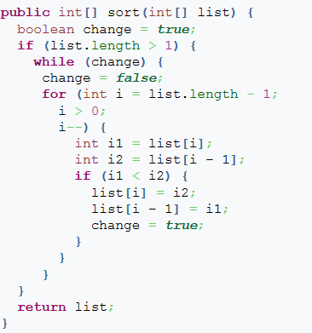
Q8.1. [10 pts.] Draw a control graph for the above method and what is the cyclomatic complexity for the module.

Q8.2. [10 pts.] Based on the number of test cases you identified for the above question, Develop the test cases for 100 % statement coverage for the module.

